# *CS432 - Computation Theory*

***Assignment #2***

***4CS-S5***

|  |  |
| --- | --- |
| ***ID*** | ***Name*** |
| 20190041 | Ahmed Tarek Fawzy Ibrahem |
| 20190562 | Mo’men Hatem Mohamed Ali |
| 20190518 | Mariam Khaled Sayed |

# Context Free Grammar

## Q1: Find a CFG for each of the following languages over the alphabet (a, b).

### Solution

### 

### 

## Q2: Find a CFG grammar of this form for the language of each of the following regular expressions.

### Solution

### Q3: Find the leftmost derivation of the word **abba** in grammar. Draw a derivation tree.

### Solution

### Q4: Find the leftmost derivation of the word **abbabaabbbabbab** in the CFG. Draw a derivation tree.

### Solution

## Q5: For the following CFGs, find regular expressions that define the same language and describe the language.

### Solution

|  |  |
| --- | --- |
| W → aW | a | W → a* |
| Z → aZ | bW | Z → a(a|b)* | b(a|b)a |
| Y → aY | a | Y → a* |
| X → aX | aY | bZ|a | X → a(a|b)*a | (a|b)*a | b(a|b)*a | a |
| S → aS | bX | a | S → a(a|b)*a | b(a|b)*a | a(a|b)*a | b(a|b)*a | a |

|  |  |
| --- | --- |
| Y → aY | bY | a | b | Y → (a|b)* |
| X → bS | aY | X → bS | a(a|b)* |
| S → bS | aX | S → b(bS|a(a|b)) | a(bS|a(a|b)) S → a(a|b)* | b(a|b)(a(a|b)|b(a|b)*) |

# Push Down Automaton

## Q6: Find a pushdown automaton for each of the following languages.

### Solution

**2-**

**3-**

## Q7: For each of the CFGs below in Problems construct a PDA that accepts the same language they generate.

1. 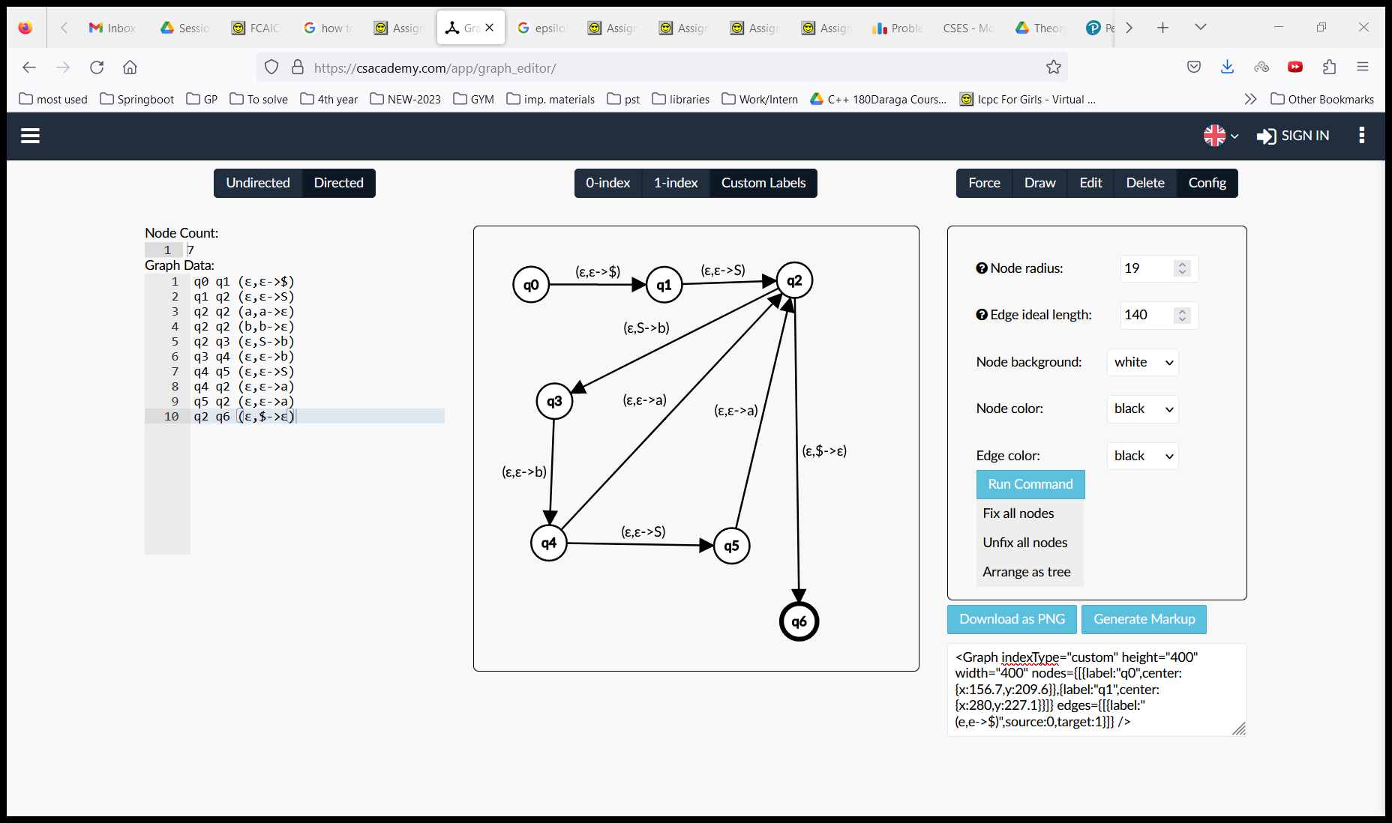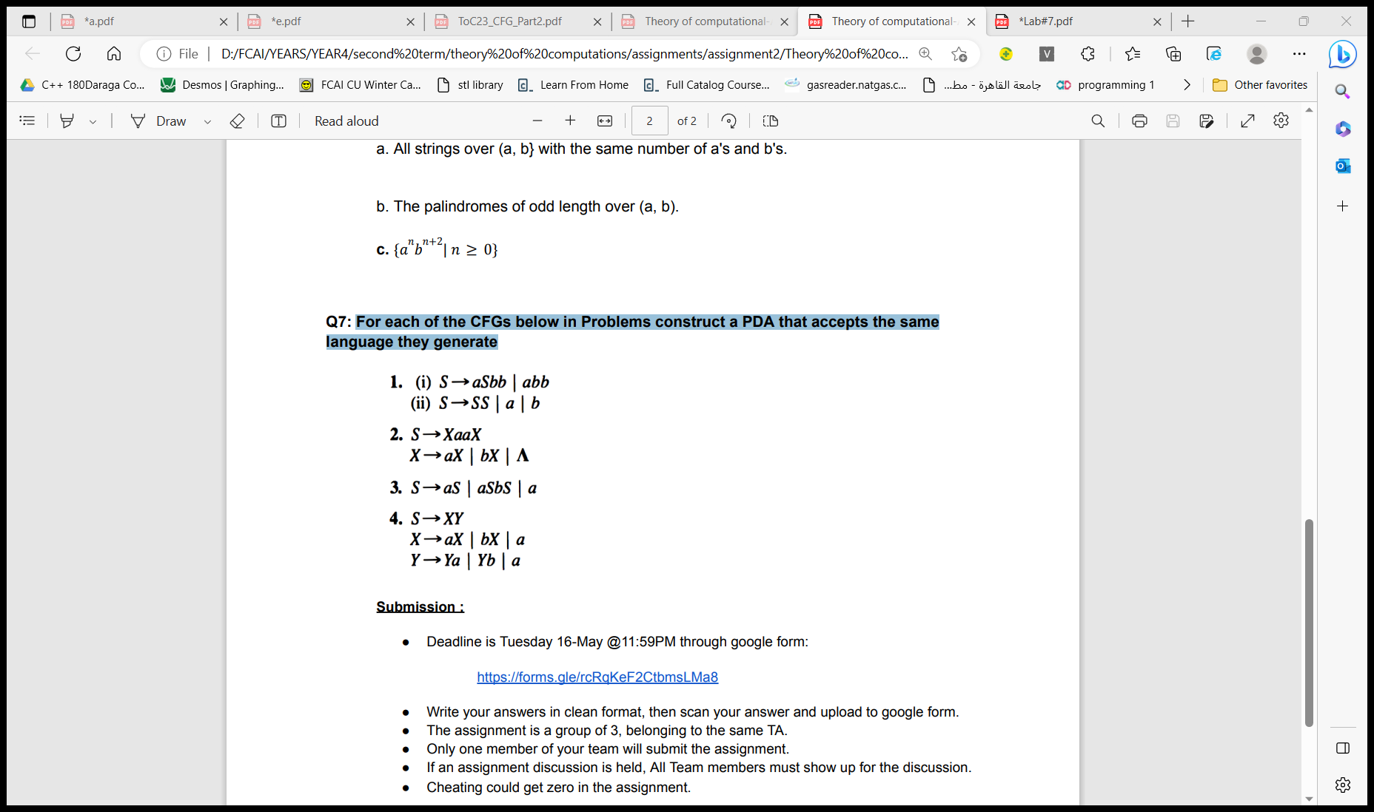

(a,a->ε)

(b,b->ε)



(ε,S->a)

### Graph Editor — Mozilla Firefox

(ε,S->b)

(a,a->ε)

(b,b->ε)

(ε,S->S)

1. 

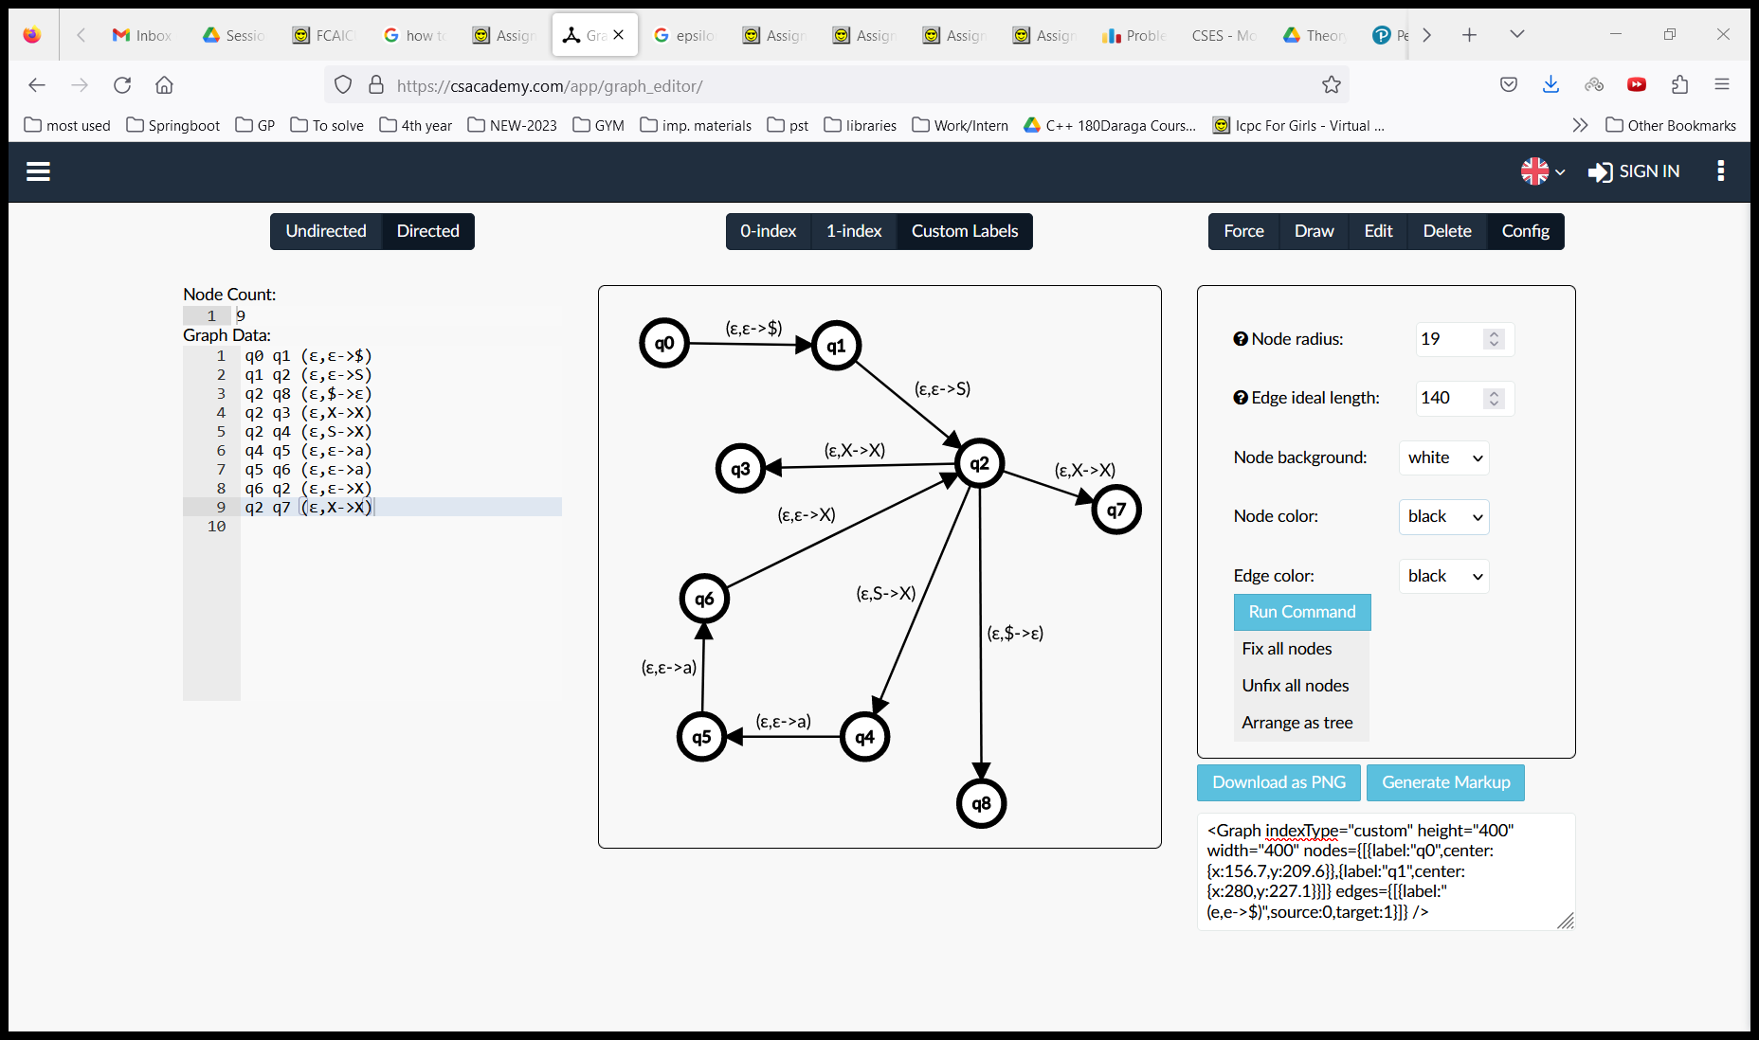

(ε,ε->a)

(ε,ε->b)

(ε,X-> ε)

(a,a->ε)

(b,b->ε)



(ε,S-> a)

(a,a->ε)

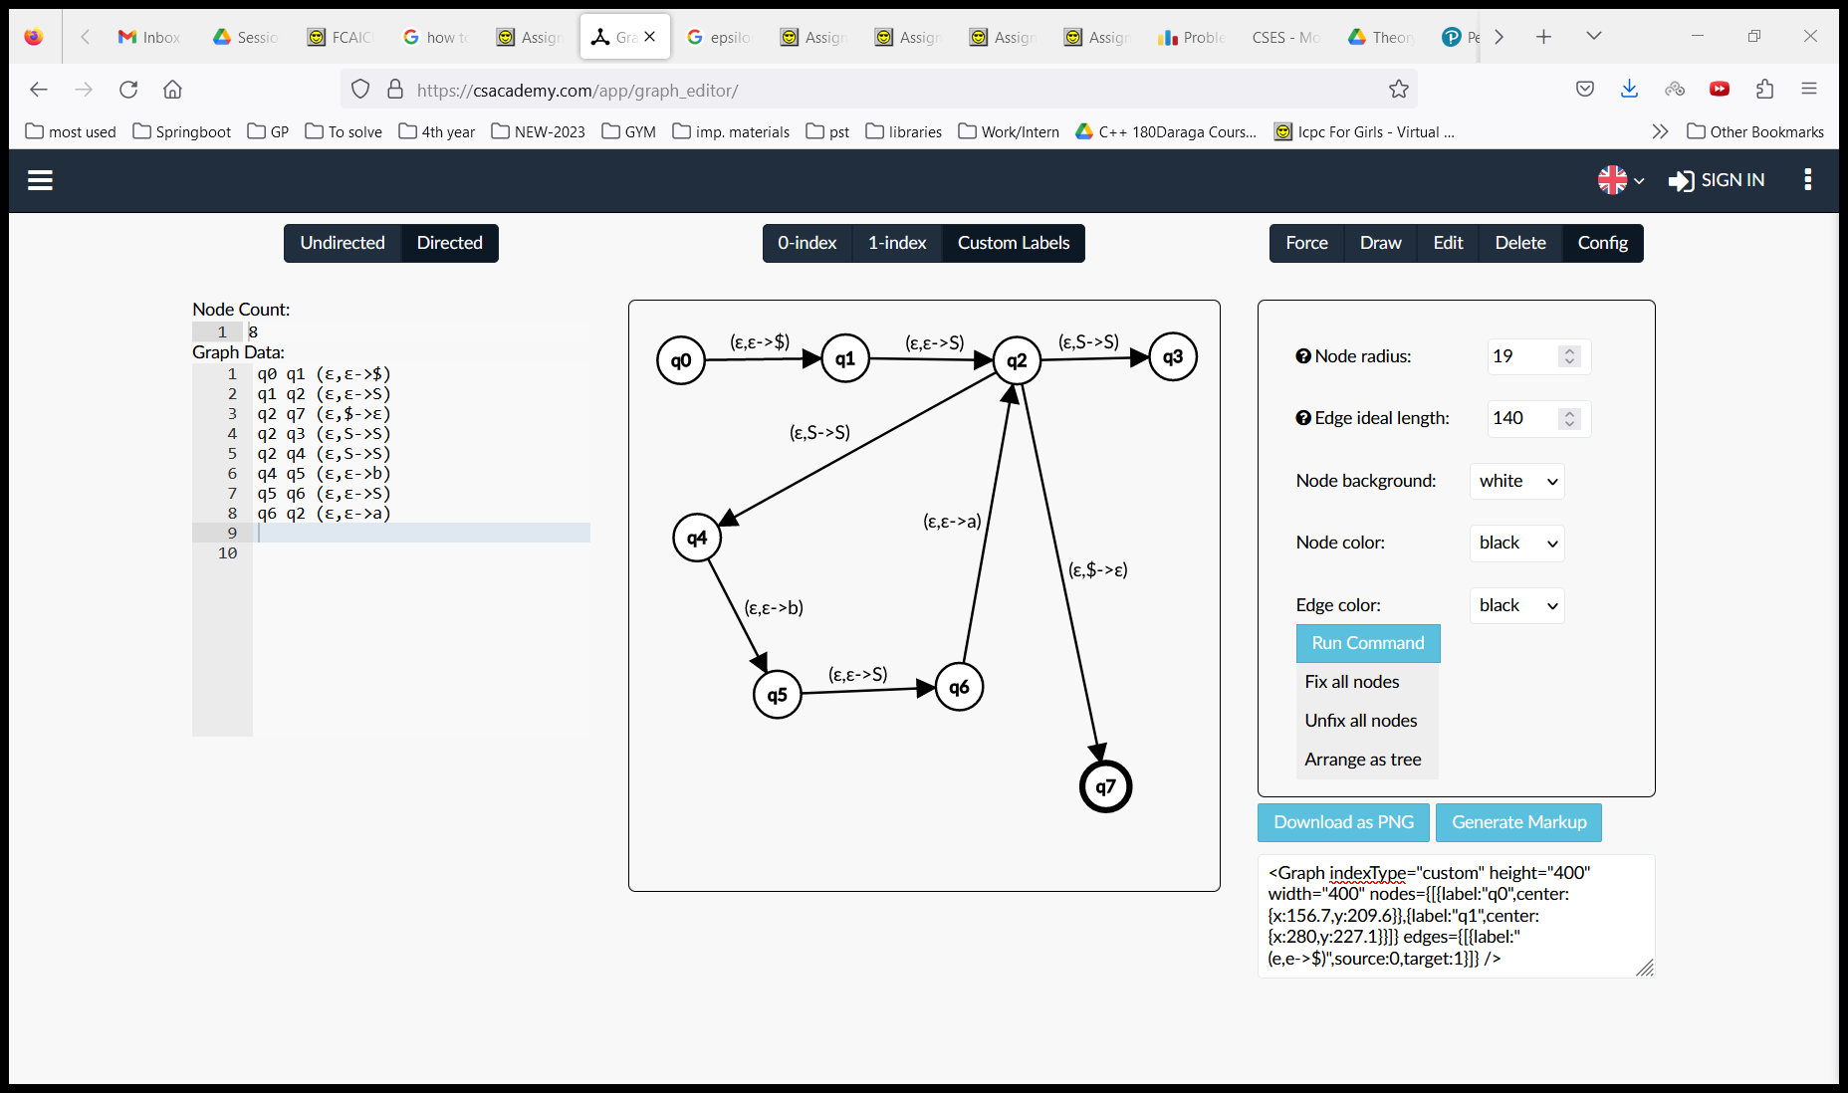

(ε,ε->a)

(a,a->ε)



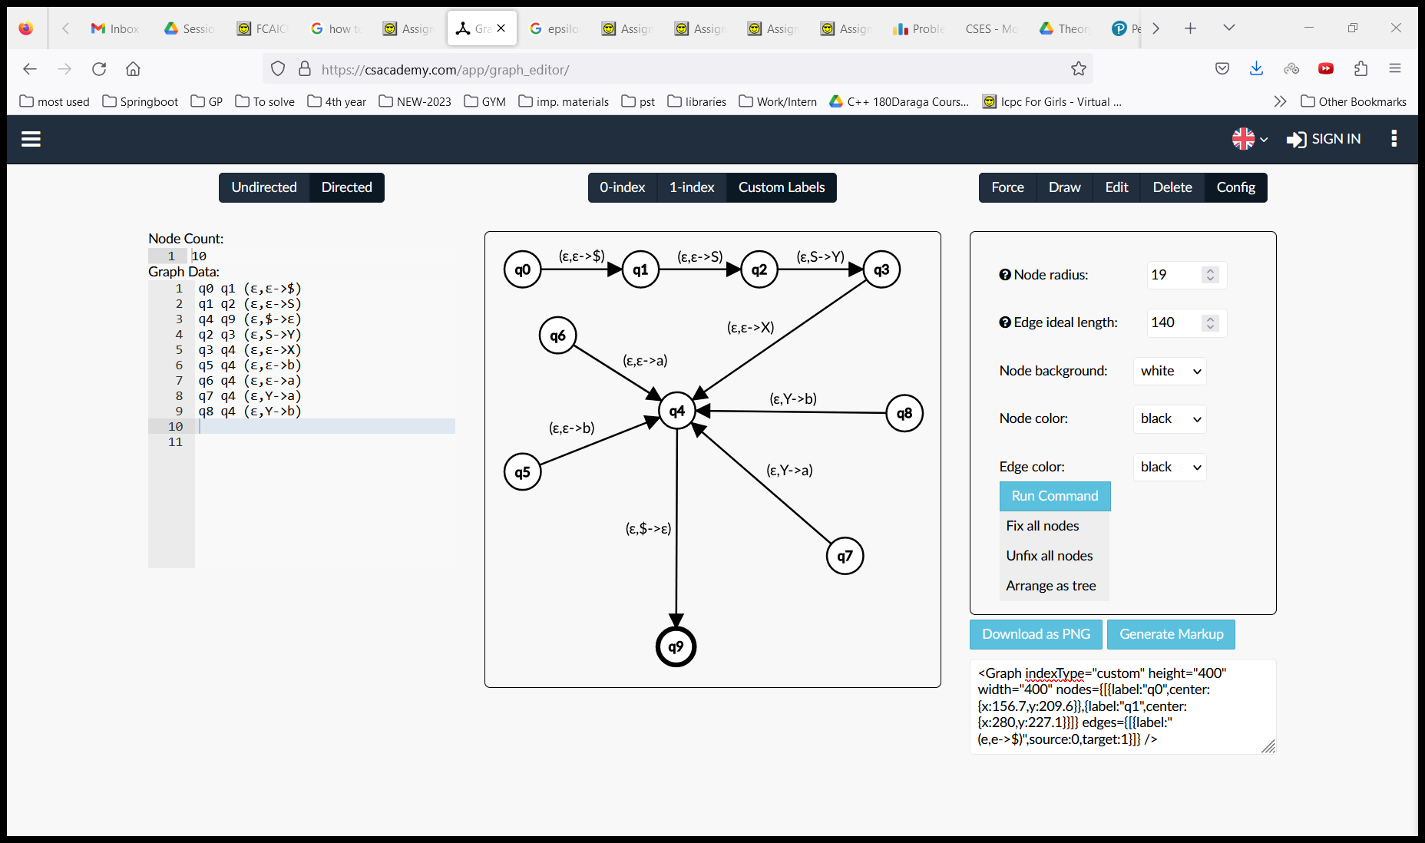

(ε,Y-> a)

(ε,X-> a)

(b,b->ε)

(a,a->ε)

(ε,Y->b)

(ε,Y->a)

(ε,X->X)

(ε,X->X)